Object Oriented Programming Using Ruby Project
(Book Store)
Your program must provide do the following:
1.A Store Item can be a book or a Magazine. A Book has a number of pages while a Magazine is published by a publisher-agent. Use inheritance to define and develop the suitable classes to represent different store items.Put all the common attributes and methods in the super class StoreItem.
Given a file book.txt and a file Magazine.txt having the following formats respectively. Assume that the files reside in the current directory of visual-studio.

Book.txt #title,price,author name,number of pages,isbn
Ruby Cookbook,100.3,Lucas Carlson,400 ,9780596523695
Ruby programming,90,Jerry Lee,200,1730497513499
Intro to Ruby,80,John Elder,550,1284396855669

Magazine.txt #title,price,publisher-agent,date
Software Magazine,13,IEEE,20-1-2022
Communications of the ACM,80,ACM,14-6-2021
eLearn,50,ACM,12-1-2021

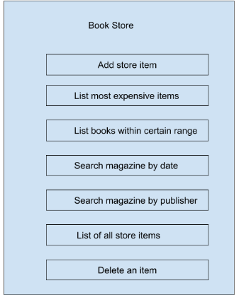
2.Book Store GUI as shown in the next figure using
flammarionhttps://github.com/zach-capalbo/flammarion

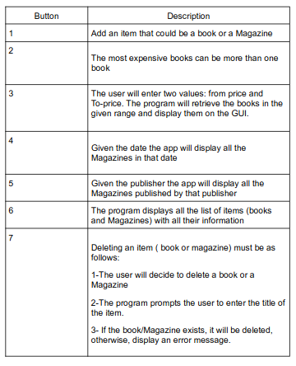

3.the LibraryManager class that corresponds to the code needed to accomplish all the operations needed by the above menu

Button7 Hint: You can use combo box/drop box control to display all books or all Magazines. Then the user can select one and clicks on delete button

